
QUALITY ALERT

Customer: United Date: July 28, 2023
Die: 15140 Colour: ALL
Type of Complaint: United COMPLAINTED

Q.A # Q.I.R # CUSTOMER NCR #

Description: United COMPLAINTED due to TIGHT when put into the punch
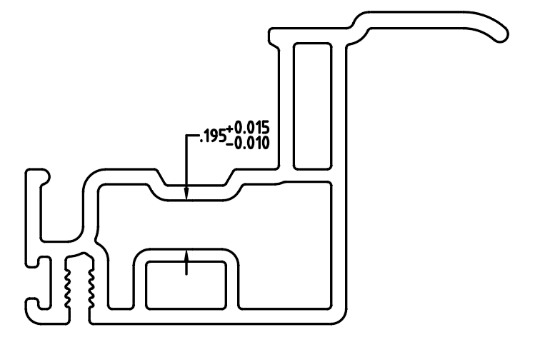

PLEASE CHECK WITH
GO NO GO GAUGE
COMPARE
GOOD SAMPLE & NO GOOD SAMPLE

PLEASE MAKE SURE THE DIMENSION MUST BE OVER 0.185”
BY SIGNING BELOW, YOU ACKNOWLEDGE THE PROBLEM ABOVE AND AGREE TO MONITOR THIS ISSUE IN FUTURE PRODUCTION RUNS.
DAY SHIFT |  | AFTERNOON SHIFT |  | NIGHT SHIFT
NAME | SIGNATURE | NAME | SIGNATURE | NAME | SIGNATURE

